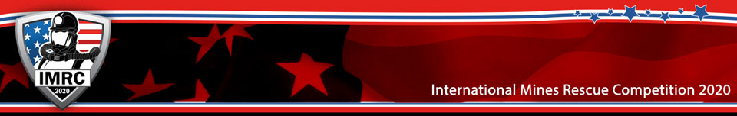
Holmes Mine Rescue Association
International Mines Rescue Competition
September 12-18, 2020
MSHA Mine Health and Safety Academy
Beaver, WV

VENDOR REGISTRATION

The competition venue will be at the MSHA Mine Health and Safety Academy,
1301 Airport Rd, Beaver, WV 25813
United States

The Official Hotel for our competition is the Glade Springs Resort. Please see our
website for accommodations information (imrc2020.com).

Firm______________________________________________

Street_____________________________________________

City___________________State_____________Zip Code_____

Telephone________________Cell________________________

Contact Person________________________________________

Vendor registration $ 500.00
Registration includes one table and two chairs, one ticket to the Opening Ceremony (Glade Springs Resort), and one ticket to the Awards Banquet. Extra tickets are available at the registration table.

Electricity required

Make check Payable to:

HMRA (International)

Attn: Mr. Lewis McCoy
PO Box 1078
Pound, VA 24279-1078

Cell: 412-418-0612
lsm@csecorporation.com

All major credit cards accepted

